20160819 Wiring Information TCT UNO

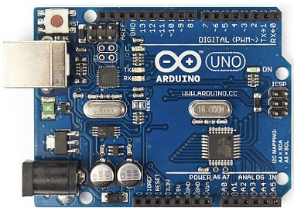

UNKNOWN

IOREF

RESET

3.3V

5V

GND

GND----------------------------------------------------+

Vin |

|

A0

A1

A2 VCC

A3 GND

A4------------------------------------------+ +---------------------- SDA

A5------------------------------------------|-------------+ +------------------SCL

+-----------------+

UNK

UNK

AREF

GND

13

12

11

10

9

8

7

6

5

4

3

2

1

0

